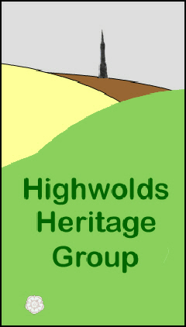
Friday 25th November

7.30pm

St. Mary’s Church, Huggate

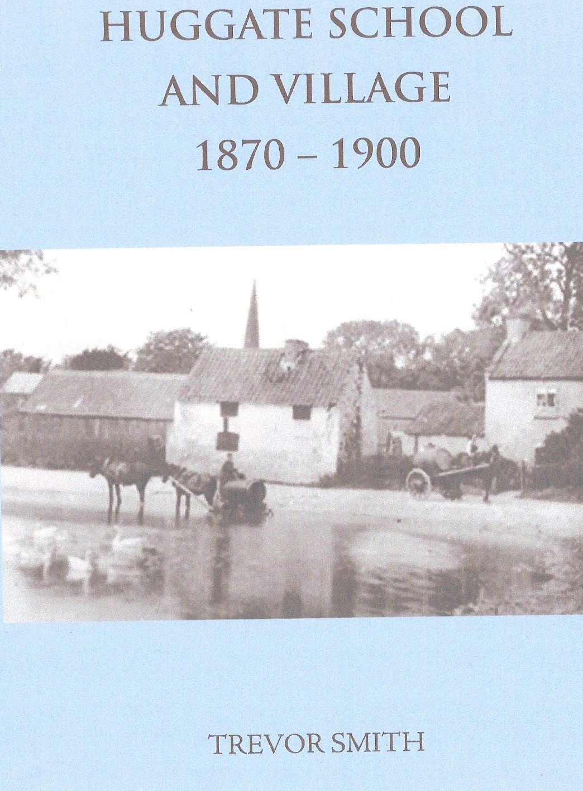
To launch this book children of

Huggate will present a short

play about the life of people

who lived in the village during

the late Victorian Age, using the

words and images of the day.

Come and find out what it was

like to live, work and study in

the village at that time.

Refreshments

Everyone is welcome

Entry is FREE

Wrap up warm !

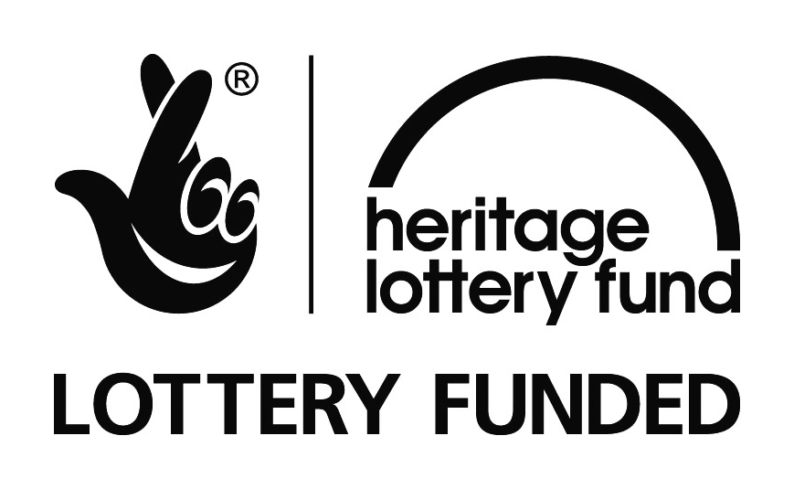
Cost £6.00
An ideal stocking filler!

